Scenario 10: you want to troubleshoot/capture information about the IP traffic going to and from network interface in our VPC [ VPC Flow logs]
VPC flow logs > cloudwatch logs > cloudwatch Insights.
We will capture and troubleshoot network traffic flowing to and from ENIs in your VPC using:
- VPC Flow Logs
- CloudWatch Logs
- CloudWatch Logs Insights (query engine)
This is widely used for:
- Debugging failed SSH/RDP connections
- Finding blocked traffic by NACL or SG
- Auditing traffic patterns
- Identifying suspicious IPs
Step 1: create VPC flow logs for your VPC and choose CloudWatch logs as the destination.
Step 2: Go to CloudWatch > logs > select the log group
- Lets create an log group first.
- Cloudwatch>logs> click on create log group
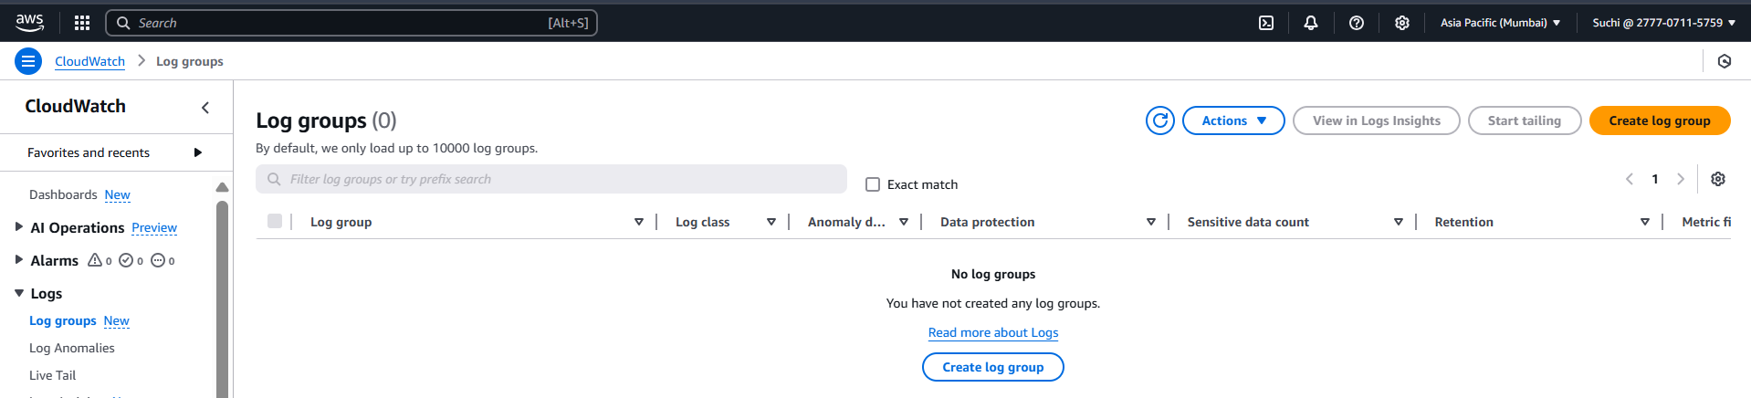
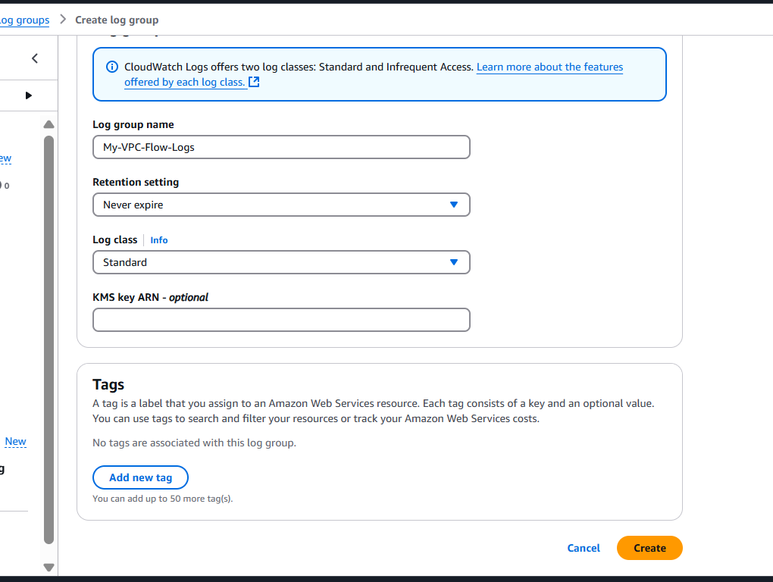

Now lets go to VPC logs and select the destination log group and select create.
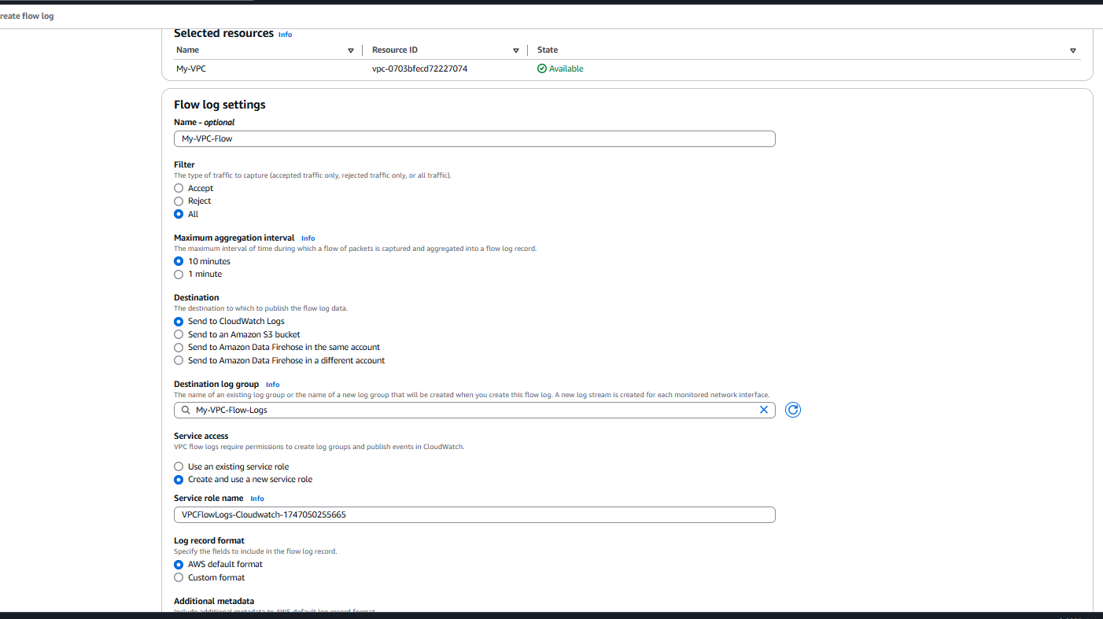

Now we could see vpc logs as been created
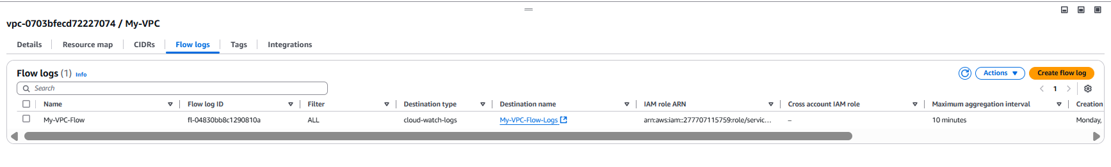
Step 3: open CloudWatch logs Insights.
Cloudwatch > logs > select the log group > click on view insights.
Step 4: run a query
Lets run a query to find blocked traffic , rejected ssh connection port 22
fields @timestamp, @ScrAddr, @dstAddr, @dstPort,action
|filter dstPort=22 and action = "REJECT"
| sort @timestamp desc
| limit 10000
This returns:
- Source IP of attacker
- Destination private IP
- Timestamp of rejection
- Action (REJECT)
- Port: 22 (SSH)
We can see the we have 2 logs for ssh connection rejections
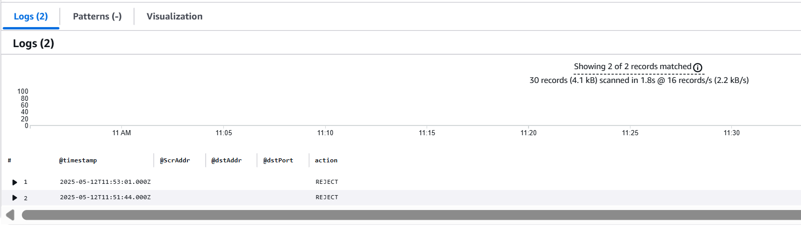
- We can also export it by csv.
- 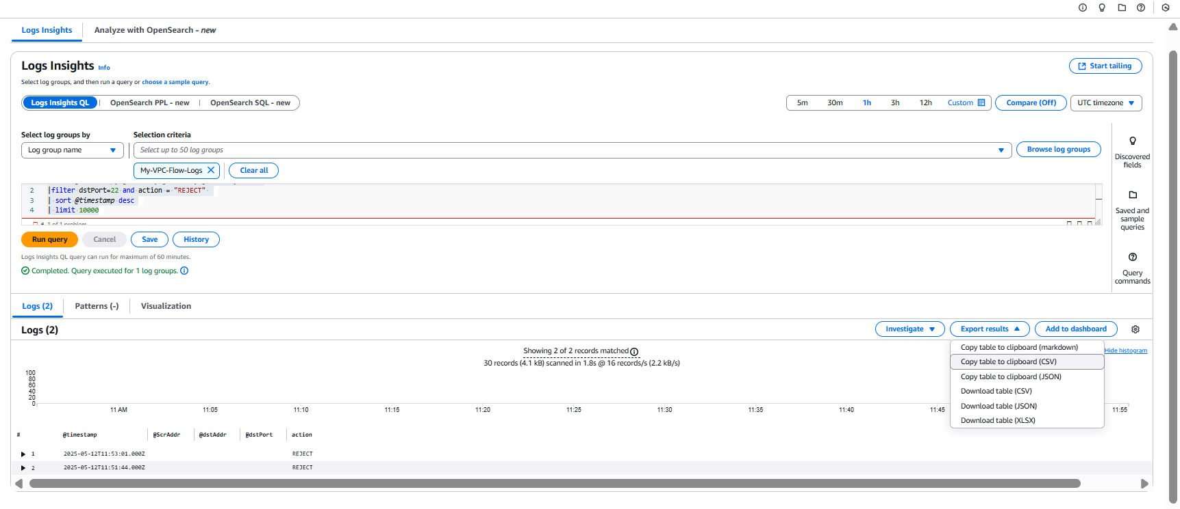

Additional Useful Queries
- Find all rejected traffic
fields @timestamp, srcAddr, dstAddr, protocol, action
| filter action = "REJECT"
| sort @timestamp desc
- Find traffic going to a specific EC2 instance
fields @timestamp, srcAddr, dstAddr, dstPort, action
| filter dstAddr = "10.0.1.25"
| sort @timestamp desc
- Find the most common IPs hitting your VPC
fields srcAddr
| stats count() by srcAddr
| sort count desc

